Practical - 2
Practical Title: Semantic HTML5 Pages with Accessibility-Ready
Structure
Problem Definition:Develop static HTML5 skeletons for at least 10 StudentHub pages such as Home, About, Register, Login, Dashboard, Events, Profile, Contact, Admin, FAQ, and Feedback. Use semantic tags and accessibility-friendly structure.
L. Theory
- Are semantic tags such as header, nav, main, section, article, aside, and footer used properly?
Answer: Yes , I used tags such as nav ,header, main, section, footer properly .
- Are form labels, headings, image alt text, and navigation links accessible?
Answer: Yes , all imgage, lables and navigation links are accessible by browser .
(using <a> and href =”link”);
- Is the page structure consistent across all pages?
Answer: Yes , all pages have consistent structure . (title,header,body,footer)
M. Implementation/ Output/Result :
<!DOCTYPE html> Declares the document as HTML5.
<html> Root element of the HTML page.
<head> Contains page information like title and CSS links.
<meta> Defines character encoding and viewport settings.
<title> Sets the title shown in the browser tab.
<link> Links an external CSS file.
<header> Defines the page header section.
<center> Centers the content (deprecated tag).
<img> Displays an image/logo.
<h1> Main heading of the page.
<h2> Section heading.
<h3> Sub-heading.
<p> Defines a paragraph.
<b> Makes text bold.
<nav> Contains navigation links.
<a> Creates hyperlinks.
<marquee> Displays scrolling text (deprecated tag).
<body> Contains all visible page content.
<main> Represents the main content of the page.
<section> Groups related content into sections.
<article> Represents independent content or an article.
<ul> Creates an unordered (bulleted) list.
<li> Defines a list item.
<hr> Inserts a horizontal line.
<footer> Defines the footer section.
- Evidence of Work (Screenshots)
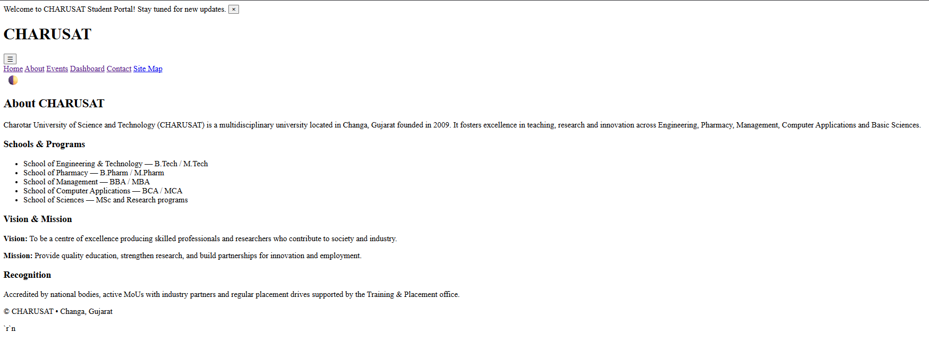
Figure 2.1(Home Page)
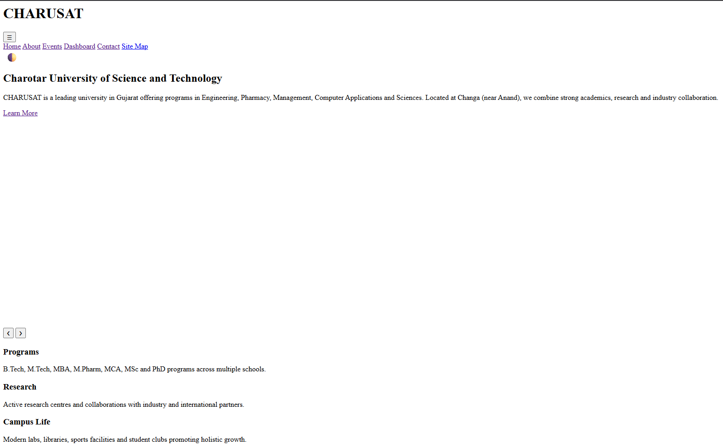
Figure 2.2(About Page)
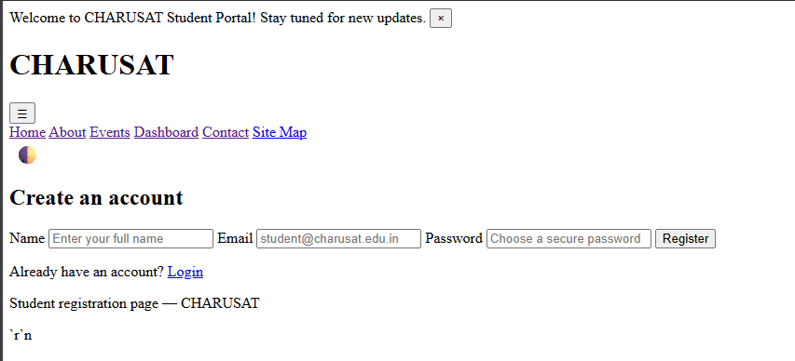
Figure 2.3(Register Page)
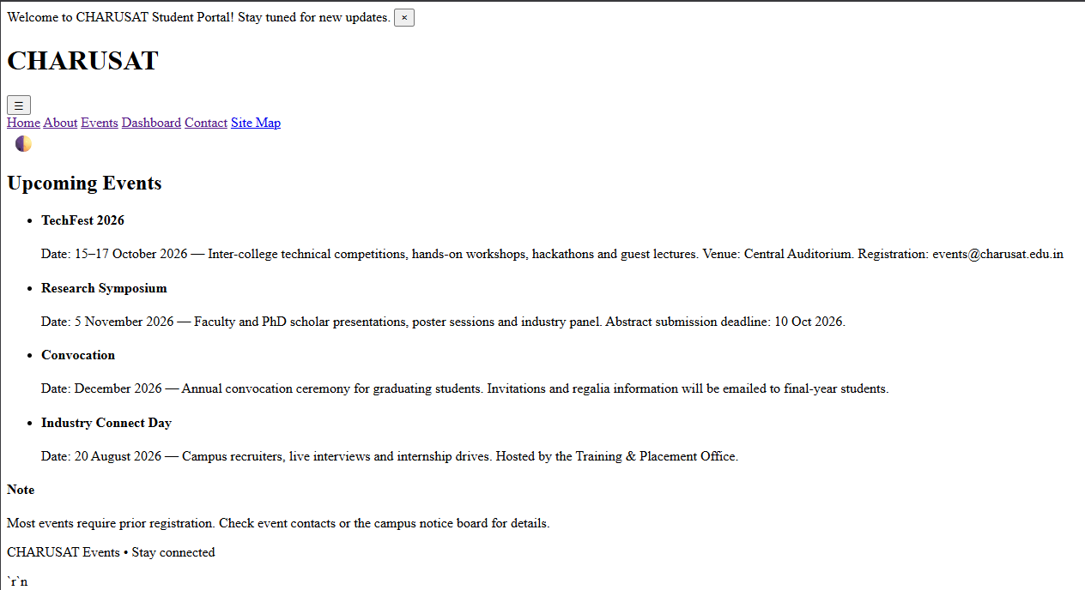
Figure 2.4(Event Page)
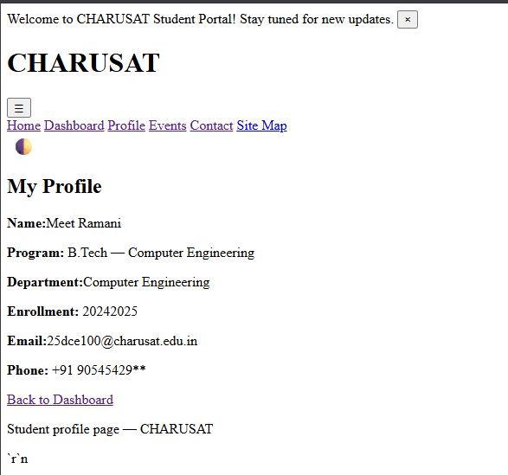
Figure 2.5
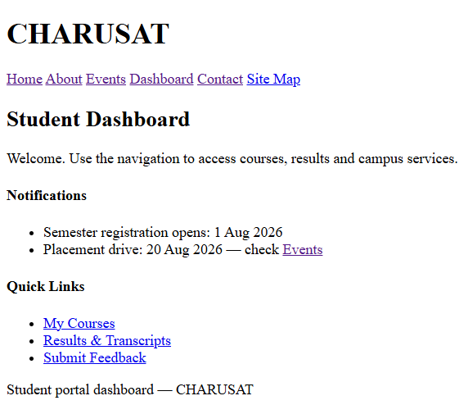
Figure 2.6
Figure 2.5 And Figure 2.6 (Dashboard Page) 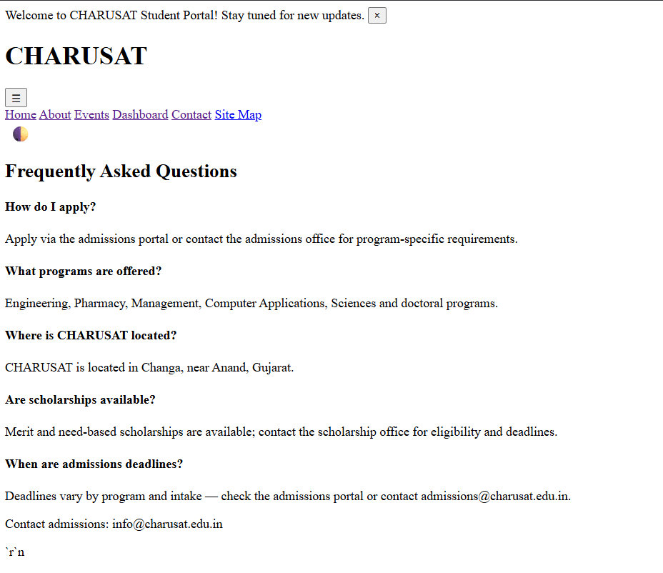
Figure 2.7(FAQ)
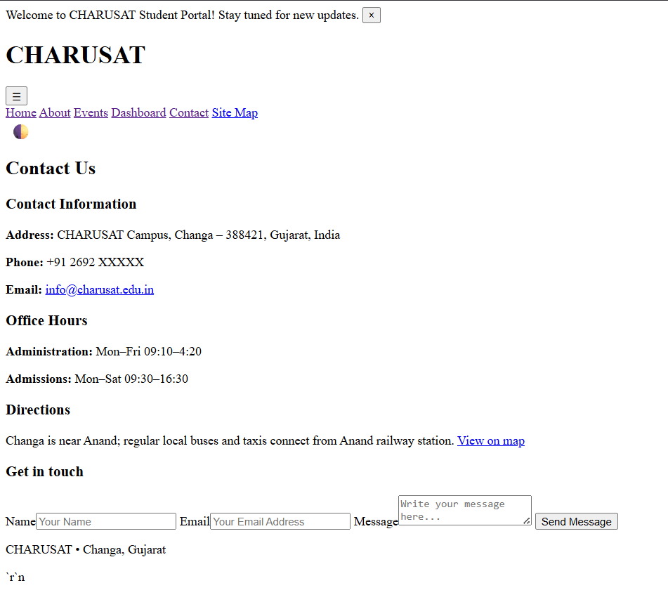
Figure 2.8 contacts
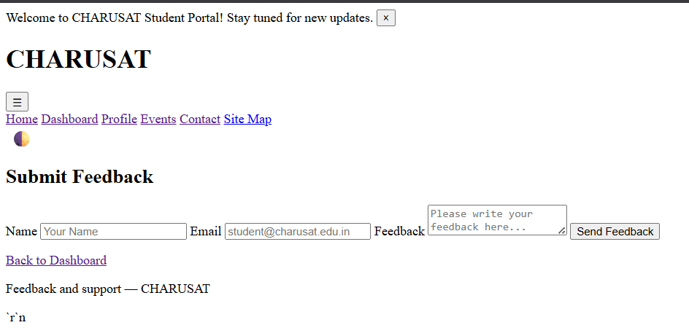
Figure 2.9(Feedback)
- GitHub Repository Link: https://github.com/meet-3834/Student-Hub

- Challenges Faced:

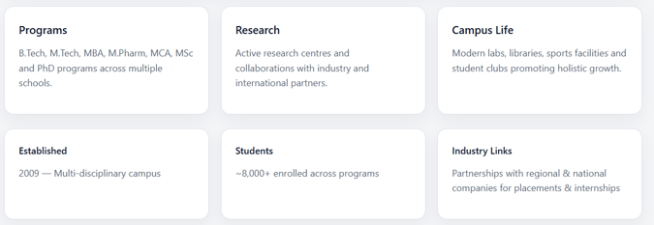
At the start of this practical, I don’t know how to create this type of sections…then I searched for it in google…in W3school website I found solution for it..

At start I am confused how my navigation flow/link will work ,then I asked for it in Ai & got particular syntax for it…

- Learning Outcomes:

By this practical , I learned about basic HTML structure & make basic Website without any fancy CSS styles.

Git Hub: - https://github.com/meet-3834/Student-Hub/tree/main/FINAL%20Submission

Faculty Remarks: (Keep this blank for faculty)

